

Pupil premium strategy statement –Ashby Fields Primary School
This statement details our school’s use of pupil premium (and recovery premium) funding to help improve the attainment of our disadvantaged pupils.
It outlines our pupil premium strategy, how we intend to spend the funding in this academic year and the outcomes for disadvantaged pupils last academic year.

School overview
Detail | Data
School name | Ashby Fields Primary School
Number of pupils in school | 402
Proportion (%) of pupil premium eligible pupils | 15% (61 children)
Academic year/years that our current pupil premium strategy plan covers (3 year plans are recommended) | 2024-2026
Date this statement was published | September 2025
Date on which it will be reviewed | September 2026
Statement authorised by | Rachel Edkins
Pupil premium lead | Emma Ramm
Governor / Trustee lead | Caroline Campbell

Funding overview
Detail | Amount
Pupil premium funding allocation this academic year | £ 86,670
Recovery premium funding allocation this academic year | £0
Pupil premium (and recovery premium*) funding carried forward from previous years (enter £0 if not applicable)  *Recovery premium received in academic year 2021 to 2022 can be carried forward to academic year 2022 to 2023. Recovery premium received in academic year 2022 to 2023 cannot be carried forward to 2023 to 2024. | £0
Total budget for this academic year  If your school is an academy in a trust that pools this funding, state the amount available to your school this academic year | £ 86,670

Part A: Pupil premium strategy plan

Statement of intent
At Ashby Fields, it is our aim for all disadvantaged students to make progress across all subjects in line with their peers both at Ashby Fields and nationally. Our Pupil Premium strategy focuses on these main areas:
- Enhancing progress with particular focus on reading, writing, phonics and early maths through quality first teaching and learning, and personalised intervention programmes, so pupils can quickly address any gaps in learning.
- Continue to provide high-quality pastoral support and PSHE Curriculum to ensure pupils know how to eat healthily, maintain an active lifestyle and are mentally healthy. We aim for all of our children and families to feel happy, safe and loved.
- Supporting children and families to access and engage in all learning, including home learning via Seesaw, to ensure that disadvantaged children are enabled to progress and consolidate learning at home regularly.
- Ensuring that teaching and learning opportunities meet the needs of all pupils.
- Ensuring that appropriate provision is made for pupils who belong to multiple vulnerable groups, including ensuring the needs of socially disadvantaged pupils are adequately assessed and addressed.
- In making provision for socially disadvantaged pupils, we recognise that not all pupils who receive free school meals will be socially disadvantaged.
- Pupil premium funding will be allocated following a needs analysis which will identify priority classes, groups or individuals. Limited funding and resources means that not all children receiving free school meals will be in receipt of pupil premium interventions at one time.
- We ensure continuous monitoring of interventions, producing impact reports to ensure these interventions are effective and are providing progression for our learners.
- Attendance is reviewed on a weekly basis, families to be supported and challenged over their attendance and strict attendance procedures in place. This is to ensure our learners are in school and are accessing their education at all times.

Demography and School Context
Ashby Fields Primary School is a community school located in Daventry, in Northamptonshire. We have fourteen classes from EYFS to Year 6. The map below displays the ‘Indices of Deprivation Index’ which surround the school.

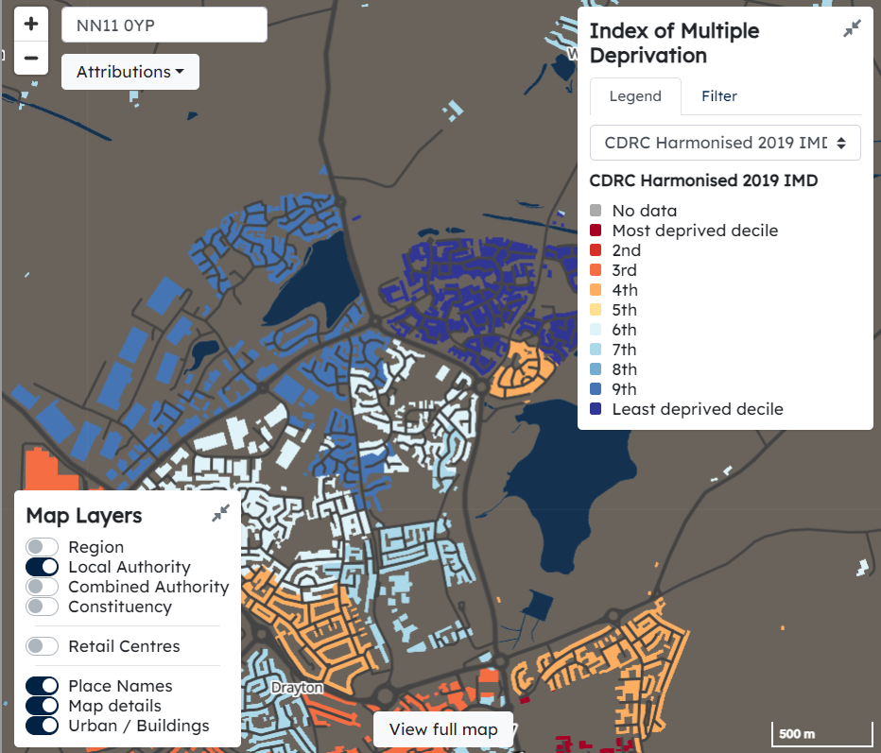

Ultimate Objectives
- To narrow the attainment gap between disadvantaged and non-disadvantaged pupils nationally and also within internal school data.
- For all disadvantaged pupils in school to exceed nationally expected progress rates in order to reach Age Related Expectation at the end of Year 2 and Year 6.

Achieving these Objectives
- ‘Catch up’ teacher, providing targeted small group work with an experienced teacher/HLTS focusing on overcoming gaps in learning.
- Additional small group and/or 1:1 support.
- Additional teaching and learning opportunities provided through trained support staff and/or external agencies.
- All work through the pupil premium will be aimed at accelerating progress, moving children to at least age-related expectations.
- Pupil premium resources are to be used to target children to achieve Age Related Expectations.
- Funding towards educational experiences, activities, trips and residentials thus ensuring children have first-hand experiences to use in their learning in the classroom.
- To develop self-image and to instil high aspirations.
- To improve attendance for PP pupils.

Challenges
This details the key challenges to achievement that we have identified among our disadvantaged pupils.
Challenge number | Detail of challenge
1 | The outcomes and progress of pupils are significantly influenced by the challenges they face beyond the classroom. Factors such as poverty, unstable home environments, limited access to enrichment opportunities, and reliance on support services create additional vulnerabilities that hinder their ability to thrive academically and socially.
2 | Our assessments, observations and discussions with pupils and families have identified social, emotional and mental health issues for a number of disadvantaged pupils, due to a lack of resilience and in a number of cases, opportunities outside of school. Teacher referrals for support (both for internal ELSA and external agencies) remain relatively high. 55% of disadvantaged pupils currently require additional support with social and emotional needs, and receive small group interventions.34% of our Pupil Premium children also have further vulnerabilities effecting their SEMH and learning needs, of which these include SEND needs.
3 | Many disadvantaged pupils face significant barriers that limit their life experiences and access to enrichment opportunities. Uptake of clubs is disproportionately low due to poverty, transport issues, and family responsibilities, while reliance on our school food bank highlights the depth of hardship in the community. These challenges, combined with reduced resilience and confidence, mean pupils struggle to engage fully in wider school life, leaving them with limited opportunities to build cultural capital and further widening the gap with their peers.
4 | Our attendance data over the last 3 years indicates that attendance among disadvantaged pupils has been between lower than for non-disadvantaged pupils. In the academic year 2024-25, 14% of disadvantaged pupils have been ‘persistently absent’ compared to 8% of their non-disadvantaged peers during that period. Our assessments and observations indicate that absenteeism is negatively impacting disadvantaged pupils’ progress.
5 | Assessments and observations show that disadvantaged pupils are particularly behind their peers in writing. This tends to be due to a lack of automaticity with the basic foundations of writing, such as letter formation, being able to make sense, full stops, capital letters, and high-frequency spellings, particularly in Key Stage 2.

Intended outcomes
This explains the outcomes we are aiming for by the end of our current strategy plan, and how we will measure whether they have been achieved.
Intended outcome | Success criteria
Improve attendance for our vulnerable pupils. | Attendance of identified PP children increases and the gap between PP and non-PP narrows.
To increase vocabulary to raise attainment in English. | Children will have an increased vocabulary learnt through:  - Use of high quality texts and vocabulary focus in reading sessions.  - Rich language environment.  - Specific interventions/pre-teaching.  - Additional 1:1 reading.  The gap between PP and non-PP diminishes.
To ensure all vulnerable children meet the National expectations in phonics. | PP children meet or exceed National expectations in the phonics screening check at the end of Year 1.  The gap between PP and non-PP diminishes.
Ensure children with multi vulnerabilities make at least expected progress from their starting points in reading, writing and maths. | As their additional needs are being addressed, PP pupils make expected progress or exceed their targets set in reading, writing and maths.
Support parents to engage in their children’s education and support them at home through supporting families in address and/or removing any barriers that are in place. | Parents indicate there are strong links between home and school with support received for a wide range of needs.  Children are provided with pastoral care, guidance and support to raise self-esteem and develop resilience, independence and perseverance.  Reduction in behaviour incidents in school due to appropriate behaviour support in the home.  Parental attendance to school run workshops to support learning at home.
Pupils access a wide range of enrichment experiences both in and out of school.  Pupils experience enjoyment in all their playtimes, improving mental health. | Pupil survey reflects enjoyment in school and improved attitudes to learning.  Social skills, independence, perseverance and teamwork are developed.

Activity in this academic year
This details how we intend to spend our pupil premium (and recovery premium) funding this academic year to address the challenges listed above.

Teaching (for example, CPD, recruitment and retention)
Budgeted cost: £26,250
Activity | Evidence that supports this approach | Challenge number(s) addressed
- Quality first teaching for all pupils is effectively monitored by the PP Champion.  - Precision Teach intervention to support with key vocabulary.  - Modelled writing within the first class quality teaching.  - Spotlight focus children with adult support.  - Pupil Progress Meetings track progress of PP pupils and appropriate, timely interventions are put in place. | - EEF guide to pupil premium – tiered approach – teaching is the top priority, including CPD.  - Sutton Trust – quality first teaching has direct impact on student outcomes.  - Training and support highly qualified teachers to deliver targeted support. | 1 + 2 + 5
- TA CPD for delivering high quality intervention for Pixl to ensure gaps identified on the QLA are addressed in the intervention. | The EEF Toolkit shows that small group tuition is effective. It has an impact because pupils in smaller groups receive greater feedback from the teacher, their engagement is sustained for longer and the work they are given is more closely matched to their needs.  As a result, small group teaching can improve learning by an additional four months’ progress over the course of a year. | 1 + 2 + 5
- Teachers and TA’s leading RWI phonics groups will receive regular coaching, modelling and training from the RWI lead.  - Those leading 1:1 phonics will receive additional training to ensure high quality teaching is taking place. Fast Track Tutoring for PP pupils who have phonic gaps. (EEF +5 months) | EEF Small group tuition: small group tuition is defined as one teacher, trained teaching assistant or tutor working with two to five pupils together in a group. This arrangement enables the teaching to focus exclusively on a small number of learners, usually in a separate classroom or working area. Intensive tuition in small groups is often provided to support lower attaining learners or those who are falling behind, but it can also be used as a more general strategy to ensure effective progress, or to teach challenging topics or skills.  +4 months | 1 + 2 + 5
- Development of oracy skills to ensure children have the building blocks for successful reading and writing. Introduction of vocabulary spines for all curriculum areas. (EEF +6) | EEF – Oral language interventions + 6 months and + 7 months in EYFS. | 1 + 2 + 5

Targeted academic support (for example, tutoring, one-to-one support, structured interventions)
Budgeted cost: £22,279
Activity | Evidence that supports this approach | Challenge number(s) addressed
Teachers to run intervention groups from Term 1 to support children to address gaps in learning and accelerate progress within RWM. | EEF Teaching and learning toolkit – one to one tuition evidence +5 months | 1 + 2
1:1 RWI phonics tutoring for identified children who are not reading at an age-appropriate level. | EEF Teaching and learning – phonics +5 months | 1 + 2
Targeted intervention for all PP children identified using PIXL therapies based upon QLA analysis. | EEF Teaching and learning – Small group tuition  +4 months when targeted from children’s personal starting points based upon QLA analysis. | 1 + 2
Home learning packs provided for all disadvantaged children to enable engagement in learning at home. | Children without access to simple tools to support home learning are less likely to engage in learning at home. Being able to practice times tables, counting, calculations, writing and having the tools to do so will enable children to access learning. EEF toolkit +4. | 1 + 5

Wider strategies (for example, related to attendance, behaviour, wellbeing)
Budgeted cost: £38,141
Activity | Evidence that supports this approach | Challenge number(s) addressed
Targeted 1:1 intervention times from Senior Inclusion Assistant to support the SEMH needs and self-esteem of PP pupils. | EEF research +4 months  Play therapy is a structured, theoretically based approach to therapy that builds on the normal communicative and learning processes of children (Carmichael, 2006; Landreth, 2002; O'Connor & Schaefer, 1983). The curative powers inherent in play are used in many ways. Therapists strategically utilize play therapy to help children express what is troubling them when they do not have the verbal language to express their thoughts and feelings (Gil, 1991). In play therapy, toys are like the child's words and play is the child's language (Landreth, 2002). Through play, therapists may help children learn more adaptive behaviours when there are emotional or social skills deficits (Pedro-Carroll & Reddy, 2005). The positive relationship that develops between therapist and child during play therapy sessions can provide a corrective emotional experience necessary for healing (Moustakas, 1997). Play therapy may also be used to promote cognitive development and provide insight about and resolution of inner conflicts or dysfunctional thinking in the child (O'Connor & Schaefer, 1983; Reddy, Files-Hall, & Schaefer, 2005). | 1 + 2
To increase PP attendance across the school.  To decrease PP PA attendance by 4%.  Developing strong relationships with parents is essential in raising  attendance. | Decrease in numbers of families at EHA, CIN, CP due to increase in families accessing early intervention from home school link worker.  Dedicated person in the role, who builds a relationship where the parents trust them and feels they will listen to them and provides them with the support they require, leads to improved relationships with school and home lives for the whole family.  Dedicated person who monitors attendance and who has a good relationship with parents is most effective at ensuring good pupil attendance.  Absence letters sent home; these will be graded according to persistence; attendance contracts will be put in place and reviewed.  Inclusion team and HT to have contract meetings for persistent absences to ensure parents are aware of the impact of children missing education.  Informal  coffee mornings with our Inclusion team will support this and enable them to also put on workshops needed as well.  EEF toolkit– Parental engagement | 1 + 4 + 5
To further support PP children with SEMH.  By July 2026, at least 85% of Pupil Premium pupils will report an improvement in their self-esteem and confidence (measured through pupil voice surveys and wellbeing check-ins) as a result of targeted interventions such as mentoring, celebration of achievements, and increased participation in enrichment activities. | Zones of regulation intervention.  Teachers and Tas will have training in delivering zones of regulation to support children to manage their emotions effectively in their learning environments.  Staff training and integration of the PACE model.  Additional support interventions including:  Time to talk  Nurture lunch  Homework provision  Positive People  Talk about programs  Yoga intervention  Research conducted by an OT who designed a curriculum geared toward helping students gain skills in consciously regulating their actions, which in turn leads to increased control and problem-solving abilities. Using a cognitive behaviour approach, the curriculum's learning activities are designed to help students recognize when they are in different states called "zones," with each of four zones represented by a different colour. In the activities, students also learn how to use strategies or tools to stay in a zone or move from one to another. Students explore calming techniques, cognitive strategies, and sensory supports so they will have a toolbox of methods to use to move between zones. To deepen students' understanding of how to self-regulate, the lessons set out to teach students these skills: how to read others' facial expressions and recognize a broader range of emotions, perspective about how others see and react to their behaviour, insight into events that trigger their less regulated states, and when and how to use tools and problem-solving skills.  EEF research +4 months | 2
Enrichment – All PP children will attend the residentials and trips this year.  Increased attendance of PP pupils to after school clubs and holiday clubs, of 15%+.  To continue to raise aspirations of PP pupils. | By Character’, we mean a set of attitudes, skills, and behaviours – such as  self-control, confidence, social skills, motivation, and resilience – that are thought to underpin success in school and beyond. These are also referred to as ‘social and emotional skills’, ‘non-cognitive skills’ or ‘essential life skills. They include the ability to respond to setbacks, work well with others, build relationships, manage emotions, and cope with difficult situations.  There is growing evidence that these skills are important to children’s later outcomes.  Careers Day  These approaches may happen during or outside of normal school hours and may seek to pursue academic goals through non-traditional means (e.g., improving maths by playing chess); develop children’s character(e.g., their motivation or resilience); or pursue wider goals because these are held to be important.  At the EEF, we think enriching education has intrinsic benefits (sometimes referred to as “arts for arts’ sake”). We think all children, including those  from disadvantaged backgrounds, deserve a well-rounded, culturally rich, education.  Aspiration intervention (EEF ) | 3
Support to pay for basic uniform to ensure all children are wearing school uniform and included. | EEF – No research conducted but for children’s wellbeing and self- esteem, we feel passionate in supporting them to have access to the same uniform as their peers.

Total budgeted cost: £ 86,670

Part B: Review of the previous academic year

Outcomes for disadvantaged pupils
Intended outcome A and B: % of pupils achieving ARE and GD in maths and reading will be closer to non-PP and closer to National expectations through quality first teaching; using pixl interventions; early identification of B1 and A2 children and regular assessment and regrouping of children.
Intended outcome D: % of PP pupils that make accelerated progress will increase through quality first teaching.
The charts below show the percentage of children who reached or exceeded the expected standard at the end of the academic year. It shows the difference between children in receipt of Pupil Premium funding and Progress in narrowing the gap between Pupil Premium children and non-Pupil Premium children has narrowed throughout the year. Further work is needed to bring Pupil Premium attainment closer in line with non-Pupil Premium.
Reading
PP Non-PP
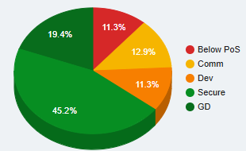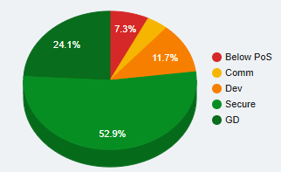
Writing
PP Non-PP
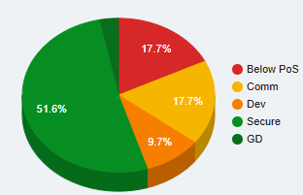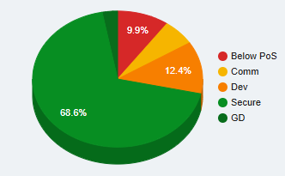
Maths
PP Non-PP
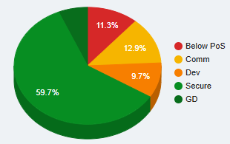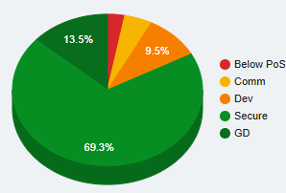
Intended outcome B: Pupil Premium attendance will be more in line with National at end of the academic year.
PP attendance at the end of the academic year was 94%. There remains a concern that more PP children are having unauthorised absences compared to non-PP.
Additional impact of spending:
School has continued to work with outside agencies. We have conducted educational psychologist assessments which has had a positive impact on the progress and engagement in school for individual children. We have worked with Occupational Health teams, to ensure Sensory and physical assessments have taken place and purchased resources needed to improve children’s ability to engage in written and physical tasks.
PIXL therapies and RWI/Fast Track Tutoring interventions have run throughout each year group, to ensure gaps in learning for all children are being identified quickly and responded to, to ensure progress can continue.
There were a small number of children with multiple vulnerabilities who are highlighted as children not managing in school. Their SEMH needs are high, and behaviour has affected themselves and other children in the class. These children have had additional support, personalise timetables and an SEMH based curriculum in place. Zones of regulation intervention and workstation strategies were taught so that the children could continue their education in a regulated way. This is proving to be successful, with increases in timetables from part time and some of the identified children reintegrating fully back into class.

Externally provided programmes
Please include the names of any non-DfE programmes that you used your pupil premium (or recovery premium) to fund in the previous academic year.
Programme | Provider
Power Maths | Active Learning
RWI | Ruth Miskin
TT Rockstars | Pixl

