 | Autumn 1 | Autumn 2 | Spring 1 | Spring 2 | Summer 1 | Summer 2
Value | Respect | Unity | Honesty | Responsibility | Kindness | Resilience
British Value | Democracy. | The rule of law. | Individual Liberty | Individual Liberty | Mutual respect | Tolerance
Ongoing throughout the Year | Time to be taught daily, highlighting times during the day that match NC age related expectations (e.g. nearest minute, compare durations of events). Roman Numerals- small display within class and children write the Roman date in their maths books daily underneath the short numerical date.
Enrichment
Reading for Pleasure | 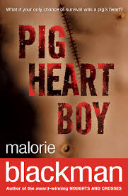 | 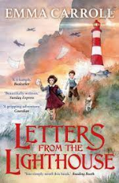 |  |  | 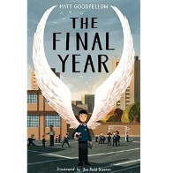 | 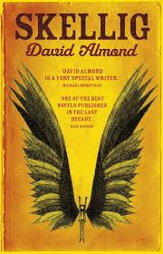
Reading |   Narrative  (Adventure)  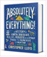  Non-Fiction  (Non-chronological report) | 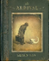  Narrative  (Picture book)    Poetry  Opening Doors to Famous Poetry and Prose  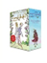  Narrative  (Tragedy) | 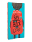  Narrative  (Friendship)    Poetry  Opening Doors to Famous Poetry and Prose  Non-Fiction  (Balanced argument)  Non-Fiction  (Explanation) | Non-Fiction  (Timeline, explanation, instructions)  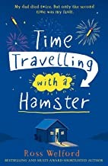  Narrative  (Science Fiction)  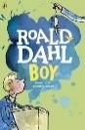  Non-Fiction  (Autobiography) | 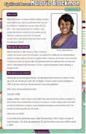  Non-Fiction  (Biography)    Narrative  (Relationships)  Narrative  (Tragedy) |   Narrative  (Special educational needs)    Playscript  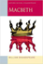  Playscript
English | 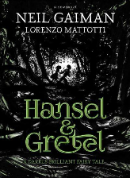  Narrative  Hansel & Gretel  Newspaper Report  Goldilocks  Postcard  Fairy Tale Characters in Prison | Narrative  The Piano Man (Flashback)  Balanced Argument  Should the light house be turned off? | Narrative  Continuation of the story  Recount  Diary vs letter from Stanley | Non-Chronological Report  Animals | 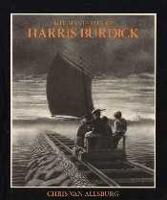  Narrative  Spooky Story | 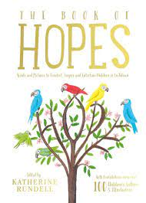  Poetry  Hope-o-potamus
Maths | Unit 1 Place value within 10,000,000  Unit 2: Four operations (1)  Unit 3: Four operations (2) | Unit 4: Fractions (1)  Unit 5: Fractions (2)  Unit 6: Measure – imperial and metric measures | Unit 7: Ratio and proportion  Unit 8: Algebra  Unit 9: Decimals | Unit 10: Percentages  Unit 11: Measure – perimeter, area and volume | Unit 12: Statistics  Unit 13: Geometry – properties of shape | Unit 14: Geometry – position and direction  Unit 15: Problem solving
Science | Animals Including Humans  The journey of a red blood cell  An explanation of the circulatory system | Light | Electricity | Electricity | Living Things and Their Habitats | Evolution and Inheritance
Computing | Communication | Web page creation | Variables in games | Introduction to spreadsheets | 3D modelling | Sensing
D&T |  | Textiles  Combining fabric shapes – slippers |  | Cooking and Nutrition  Celebrating Culture and Seasonality – Fruit crumble |  | Mechanims  CAMs – Create a toy
Art & Design | Drawing |  | Printing |  | Sculpture
History |  | The Blitz WW2 |  | The Mayan Civilisation |  | Crime and Punishment
Geography | Wonderous Wales |  | Fair Trade 1 |  | Fair Trade 2
RE | Core beliefs, traditions, and celebrations  Christianity  Humanists | Core beliefs, traditions, and celebrations  Christianity  Humanists | Key people and places  Hinduism | Key people and places  Hinduism | RE moving into the wider community | RE moving into the wider community
Music | Unit 1 World Unite | MB – Christmas Carol | Unit 3 Growth | MB – Mr Blue Skies | Unit 6 Moving On | MB Viva La Viva
MFL | Phonetics Lesson 4  P: At School | P: Healthy Lifestyle | P: At the Weekend | P: World War II | P: Me in the World | P: Vikings
PE | Real PE – Personal Cog  Games  - use running, jumping, throwing and catching in isolation and in combination  - play competitive games, modified where appropriate [for example, badminton, basketball, cricket, football, hockey, netball, rounders and tennis], and apply basic principles suitable for attacking and defending  - compare their performances with previous ones and demonstrate improvement to achieve their personal best. | Real PE – Social Cog  Gym  - use running, jumping, throwing and catching in isolation and in combination  - develop flexibility, strength, technique, control and balance [for example, through athletics and gymnastics]  - compare their performances with previous ones and demonstrate improvement to achieve their personal best. | Real PE – Cognitive Cog  Dance  - use running, jumping, throwing and catching in isolation and in combination  - perform dances using a range of movement patterns | Real PE – Creative Cog  Swimming  - use running, jumping, throwing and catching in isolation and in combination  - develop flexibility, strength, technique, control and balance [for example, through athletics and gymnastics]  - compare their performances with previous ones and demonstrate improvement to achieve their personal best.  - swim competently, confidently and proficiently over a distance of at least 25 metres  - use a range of strokes effectively [for example, front crawl, backstroke and breaststroke]  - perform safe self-rescue in different water-based situations. | Real PE – Physical Cog  Athletics  - use running, jumping, throwing and catching in isolation and in combination  - develop flexibility, strength, technique, control and balance [for example, through athletics and gymnastics]  - compare their performances with previous ones and demonstrate improvement to achieve their personal best. | Real PE – Health & Fitness Cog  Assessed Gaps / Adventure  • use running, jumping, throwing and catching in isolation and in combination  • play competitive games, modified where appropriate [for example, badminton, basketball, cricket, football, hockey, netball, rounders and tennis], and apply basic principles suitable for attacking and defending  • develop flexibility, strength, technique, control and balance [for example, through athletics and gymnastics]  • perform dances using a range of movement patterns  • take part in outdoor and adventurous activity challenges both individually and within a team  • compare their performances with previous ones and demonstrate improvement to achieve their personal best.
PSHE | Relationships (InMAT) | Valuing Difference (Scarf) / Being My Best (Scarf) | Living in the Wider World (InMAT) | Keeping Safe (Scarf) | Health and Well-Being (InMAT) | Growing and Changing (Scarf)

