 | Autumn 1 | Autumn 2 |  | Spring 1 |  |  | Spring 2 |  | Summer 1 | Summer 2
Value | Respect | Unity |  | Honesty |  |  | Responsibility |  | Kindness | Resilience
British Value | Democracy. | The rule of law. |  | Individual Liberty |  |  | Individual Liberty |  | Mutual respect | Tolerance
Ongoing throughout the Year | Time to be taught daily, highlighting times during the day that match NC age related expectations (e.g. nearest minute, compare durations of events). Roman Numerals- small display within class and children write the Roman date in their maths books daily underneath the short numerical date.
Enrichment | Zoo trip | Ancient Greek day  Panto/cinema |  |  |  |  | Author Visit |  | Space Centre
Reading for Pleasure |  |  |  |  |  |  | Kick  |  | 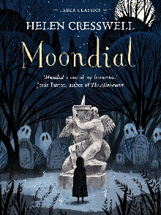 | 
Reading | Beetle Boy  Coming to England by Floella Benjamin  The Highwayman By Alfred Noyes | The Wonder Garden by Jenny Bloom and Kristjana Williams  The Bad Beginning: a series of Unfortunate Events by Lemony Snicket  TV Advert- John Lewis (Buster) |  | Wild is the wind by Grahame Baker-Smith  The kitten and falling leaves’ by William Wordsworth  ‘Journey to the centre of the Earth’ by Jules Verne  Opening Doors to Famous Poetry and Prose  Extinct by Hainan Gibbon  The Story of Life on Earth by Ben Garrod |  |  | When Hitler Stole Pink Rabbit By  Judith Kerr  The What on Earth? Wallbook Timeline of Big History  By Christopher Lloyd.  ‘The Eagle’ by Alfred, Lord Tennyson  ‘The Inchcape Rock’ by Robert Southey  Opening Doors to Famous Poetry and Prose |  | Boy In the Tower by Polly Ho-Yen  National Geographic Kids Magazine  Cloud Soup by Kate Weakling (poetry)  T he Mysteries of the Universe by Will Gate | Charles Dickens England’s Most Captivating Storyteller  Ghost of Thomas Kempe by Penelope Lively  50 Most Famous poems: Emily  Dickinson,
English | 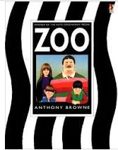  Narrative  Non-chronological report: Emperor Penguins | 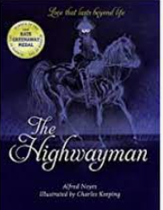  Poetry  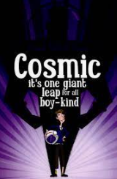  Narrative |  | Biography- David Attenborough  Narrative- description  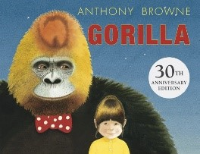 |  |  | Persuasive Letter (NF)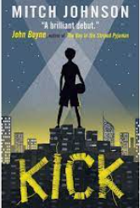  Narrative  The Present by Jacob Frey (Short Film) |  | Non-fiction: Mars Transition (NF)  Poetry: The Malfeasance | Speech: Refugees (NF)    Narrative
Maths | Unit 1: Place value within 1000,000 (1)  Unit 2: Place value within 1000,000 (2)  Unit 3: Addition and subtraction | Unit 4: Multiplication and division (1)  Unit 5: Fractions (1)  Unit 6: Fractions (2) |  | Unit 7: Multiplication and division (2)  Unit 8: Fractions (3)  Unit 9: Decimals and percentages |  |  | Unit 10: Measure – perimeter and area  Unit 11: Graphs and tables |  | Unit 12: Geometry – properties of shapes  Unit 13: Geometry – position and direction  Unit 14: Decimals | Unit 15: Negative numbers  Unit 16: Measure – converting units  Unit 17: Measure – volume
Science | Forces | Living Things and Their Habitats | Properties and changes in materials |  | Properties and their changes in materials | Earth and Space |  | Animals Including Humans
Computing | Sharing information | Video editing |  | Selection in physical computing |  |  | Flat-file databases |  | Vector drawing | Selection in quizzes
D&T |  | Cooking and Nutrition  Celebrating Culture and Seasonality – Pizza |  |  |  |  | Structures  Frame Structures – Make a bird hide |  |  | Mechanisms  Pulleys or Gears – Fairground ride
Art & Design | Collage |  |  | Textiles |  |  |  |  | Painting
History |  | Ancient Greece |  |  |  |  | The Aztecs |  |  | The Battle of Naseby
Geography | Vaparous Volcanoes |  |  | Exuberant Earthquakes |  |  |  |  | Rampaging Romans
RE | Core beliefs, traditions, and celebrations  Judaism  Sikhism | Core beliefs, traditions, and celebrations  Judaism  Sikhism |  | Key people and places  Sikhism  Christianity  Islam |  |  | Key people and places  Sikhism  Christianity  Islam |  | Important books and religious stories  Christianity  Sikhism | Important books and religious stories  Christianity  Sikhism
Music | MB You are the sunshine | Unit 3 Life Cycles |  | MB Blinding Lights |  |  | Unit 2 Solar System |  | MB Sing | Unit 4 Keeping Healthy
MFL | Phonetics Lesson 3  I: Do You Have a Pet? | I: My Home |  | I: The Date |  |  | I: Habitats |  | I: Clothes | I: The Olympics
PE | Real PE – Personal Cog  Swimming  - use running, jumping, throwing and catching in isolation and in combination  - compare their performances with previous ones and demonstrate improvement to achieve their personal best.  - swim competently, confidently and proficiently over a distance of at least 25 metres  - use a range of strokes effectively [for example, front crawl, backstroke and breaststroke]  - perform safe self-rescue in different water-based situations. | Real PE – Social Cog  Gym  - use running, jumping, throwing and catching in isolation and in combination  - develop flexibility, strength, technique, control and balance [for example, through athletics and gymnastics]  - compare their performances with previous ones and demonstrate improvement to achieve their personal best. |  | Real PE – Cognitive Cog  Dance  - use running, jumping, throwing and catching in isolation and in combination  - perform dances using a range of movement patterns  - compare their performances with previous ones and demonstrate improvement to achieve their personal best. |  |  | Real PE – Creative Cog  Games  - use running, jumping, throwing and catching in isolation and in combination  - play competitive games, modified where appropriate [for example, badminton, basketball, cricket, football, hockey, netball, rounders and tennis], and apply basic principles suitable for attacking and defending  - develop flexibility, strength, technique, control and balance [for example, through athletics and gymnastics]  - compare their performances with previous ones and demonstrate improvement to achieve their personal best. |  | Real PE – Physical Cog  Athletics  - use running, jumping, throwing and catching in isolation and in combination  - develop flexibility, strength, technique, control and balance [for example, through athletics and gymnastics]  - compare their performances with previous ones and demonstrate improvement to achieve their personal best. | Real PE – Health & Fitness Cog  Assessed Gaps / Adventure  - use running, jumping, throwing and catching in isolation and in combination  - play competitive games, modified where appropriate [for example, badminton, basketball, cricket, football, hockey, netball, rounders and tennis], and apply basic principles suitable for attacking and defending  - develop flexibility, strength, technique, control and balance [for example, through athletics and gymnastics]  - perform dances using a range of movement patterns  - take part in outdoor and adventurous activity challenges both individually and within a team  - compare their performances with previous ones and demonstrate improvement to achieve their personal best.
PSHE | Relationships (InMAT) | Valuing Difference (Scarf) / Being My Best (Scarf) |  | Living in the Wider World (InMAT) |  |  | Keeping Safe (Scarf) |  | Health and Well-being (InMAT) | Growing and Changing (Scarf)

