 | Autumn 1 |  |  | Autumn 2 |  | Spring 1 |  |  | Spring 2 | Summer 1 | Summer 2
Value | Respect |  |  | Unity |  | Honesty |  |  | Responsibility | Kindness | Resilience
British Value | Democracy. |  |  | The rule of law. |  | Individual Liberty |  |  | Individual Liberty | Mutual respect | Tolerance
Ongoing throughout the Year | Time to be taught daily, highlighting times during the day that match NC age related expectations (e.g. nearest minute, compare durations of events). Roman Numerals- small display within class and children write the Roman date in their maths books daily underneath the short numerical date.
Enrichment
Reading for Pleasure |  |  |  |  |  |  |  |  |  |  | 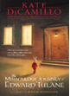
Reading | 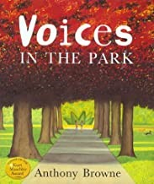  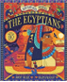 |  |  | 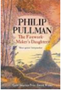   |  | 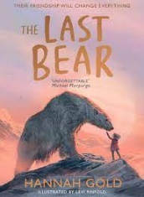   |  |  | 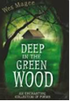  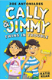 | 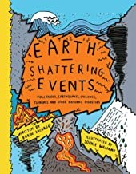  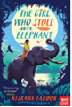 | 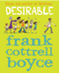  
English | 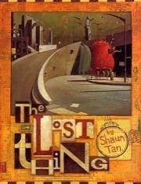  The lost thing – Narrative  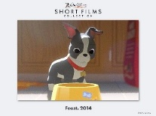  Feast – Narrative |  |  |   Narrative -  Aladdin and the enchanted lamp  Poem – The River |  | 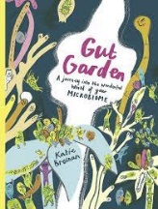  Non- fiction -  Digestion  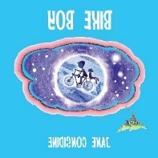  Narrative -  Bike boy |  |  | 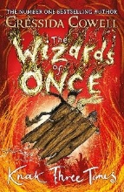  Newspaper report -  Wizards of once  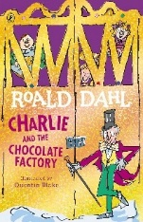  Narrative -  Charlie and the chocolate factory | 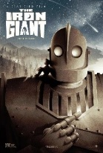  Narrative -  The Iron Man  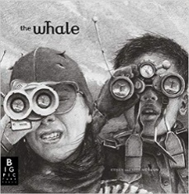  Narrative -  The Whale | 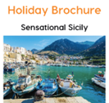  Nonfiction – Persuasive  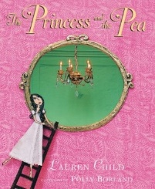  Narrative -  The princess and the pea
Maths | Unit 1: Place value – 4-digit numbers (1)  Unit 2: Place value – 4-digit numbers (2)  Unit 3: Addition and subtraction |  |  | Unit 4: Area  Unit 5: Multiplication and division (1) |  | Unit 6: Multiplication and division (2)  Unit 7: Length and perimeter  Unit 8: Fractions (1) |  |  | Unit 9: Fractions (2)  Unit 10: Decimals (1) | Unit 11: Decimals (2)  Unit 12: Money  Unit 13: Time | Unit 14: Geometry – angles and 2D shapes  Unit 14: Statistics
Science | Animals including humans |  |  | Sound |  | Electricity |  |  | Electricity | Living Things in their Habitat | States of Matter
Computing | The internet |  |  | Audio editing |  | Repetition in shapes |  |  | Data logging | Photo editing | Repetition in games
D&T |  |  |  | Electrical System  Simple circuits – Make a night light |  |  |  |  | Mechanisms  Pneumatics – Moving Toy |  | Cooking and Nutrition  Healthy and Varied Diet - Sandwiches
Art & Design | Drawing |  |  |  |  | Sculpture |  |  |  | Printing
History |  |  |  | Ancient Egypt |  |  |  |  | The Tudors |  | The Anglo-Saxons
Geography | Rainforests |  |  |  |  | Rainforests 2 |  |  |  | I live in Daventry
RE | Core beliefs, traditions, and celebrations  Christianity  Humanism |  |  | Core beliefs, traditions, and celebrations  Christianity  Humanism |  | Key people and places  Islam  Muslim  Jewish |  |  | Key people and places  Islam  Muslim  Jewish | Important books and religious stories  Christianity  Muslim | Important books and religious stories  Christianity  Muslim
Music | Autumn 1  ‘Lean on me’ MB | Autumn 2  Unit 1: Poetry  Unit 2 Environment | Spring 1  ‘Obla Di Obla Da’ MB |  | Spring 2  Unit 4: Recycling  Unit 6: Around the worlds |  | Summer 1  ‘I feel fine’ MB | Summer 2  Unit 10: Time  Unit 11: In the past
MFL | Phonetics Lesson 2  I: My Family |  |  | I: In the Classroom |  | I: Presenting Myself |  |  | I: Goldilocks | I: At the Tearoom | I: What is the Weather
PE | Real PE – Personal Cog  Games  - use running, jumping, throwing and catching in isolation and in combination  - play competitive games, modified where appropriate [for example, badminton, basketball, cricket, football, hockey, netball, rounders and tennis], and apply basic principles suitable for attacking and defending  - compare their performances with previous ones and demonstrate improvement to achieve their personal best. |  |  | Real PE – Social Cog  Gym  - use running, jumping, throwing and catching in isolation and in combination  - develop flexibility, strength, technique, control and balance [for example, through athletics and gymnastics]  - compare their performances with previous ones and demonstrate improvement to achieve their personal best. |  | Real PE – Cognitive Cog  Dance  - use running, jumping, throwing and catching in isolation and in combination  - perform dances using a range of movement patterns  - compare their performances with previous ones and demonstrate improvement to achieve their personal best. |  |  | Real PE – Creative Cog  Assessed Gaps / Adventure  - use running, jumping, throwing and catching in isolation and in combination  - play competitive games, modified where appropriate [for example, badminton, basketball, cricket, football, hockey, netball, rounders and tennis], and apply basic principles suitable for attacking and defending  - develop flexibility, strength, technique, control and balance [for example, through athletics and gymnastics]  - perform dances using a range of movement patterns  - take part in outdoor and adventurous activity challenges both individually and within a team  - compare their performances with previous ones and demonstrate improvement to achieve their personal best. | Real PE – Personal Cog  Swimming  - use running, jumping, throwing and catching in isolation and in combination  - develop flexibility, strength, technique, control and balance [for example, through athletics and gymnastics]  - compare their performances with previous ones and demonstrate improvement to achieve their personal best. | Real PE – Personal Cog  Athletics  - use running, jumping, throwing and catching in isolation and in combination  - technique, control and balance [for example, through athletics and gymnastics]  - compare their performances with previous ones and demonstrate improvement to achieve their personal best.
PSHE | Relationships (InMAT) |  |  | Valuing Difference (Scarf) / Being My Best (Scarf) |  | Living in the Wider World (InMAT) |  |  | Keeping Safe (Scarf) | Health and Well-being (InMAT) | Growing and Changing (Scarf)

