 | Autumn 1 | Autumn 2 | Spring 1 | Spring 2 | Summer 1 | Summer 2
Value | Respect | Unity | Honesty | Responsibility | Kindness | Resilience
British Value | Democracy. | The rule of law. | Individual Liberty | Individual Liberty | Mutual respect | Tolerance
Ongoing throughout the Year | Time to be taught daily, highlighting times during the day that match NC age related expectations (e.g. nearest minute, compare durations of events). Roman Numerals- small display within class and children write the Roman date in their maths books daily underneath the short numerical date.
Enrichment
Reading for Pleasure |  |  |  |  | 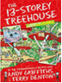 | 
Reading | 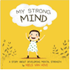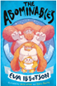 | 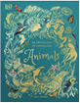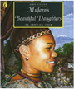 | 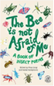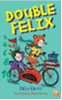 | 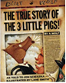 | 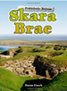 | 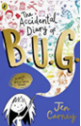
English | Narrative  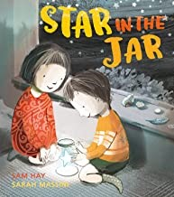  Poetry  (Seasonal poetry)  Autumn is Here | Narrative  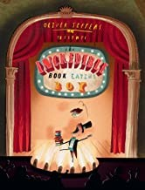  Non-Fiction- skeletons and muscles  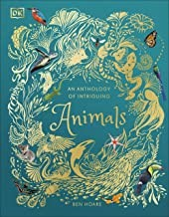 | Narrative  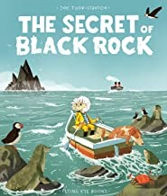  Poetry  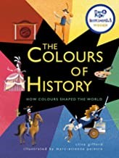 | Narrative 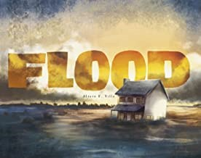  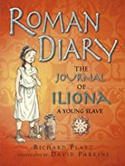  The Journal of Iliona – A Young Slave. | Narrative  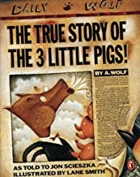  Instructions  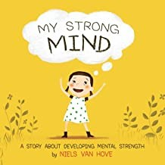 | Narrative  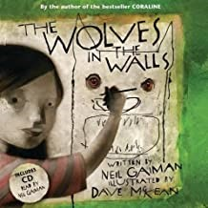  Persuasive writing- holiday brochures  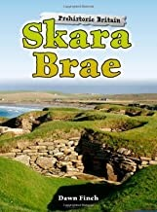
Maths | Unit 1: Place value within 1,000  Unit 2: Addition and subtraction (1) | Unit 3: Addition and subtraction (2)  Unit 4: Multiplication and division (1)  Unit 5: Multiplication and division (2) | Unit 6: Multiplication and division (3)  Unit 7: Length and perimeter  y | Unit 8: Fractions (1)  Unit 9: Mass  Unit 10: Capacit | Unit 10: Fractions  Unit 11: Time  Unit 12: Problem solving and efficient methods | Unit 13: Position and direction  Unit 14: Weight, volume and temperature
Science | Plants | Use of everyday materials | Animals | Forces and Magnets | Light and Shadows | Working scientifically
Computing | Connecting computers | Stop-frame Animation | Sequence in music | Branching Databses | Desktop publishing | Events and actions
D&T |  | Cooking and Nutrition  Healthy and Varied Diet  Soup |  | Structure  Shell Structures – Gift Box |  | Mechanisms  Levers and Linkages – create a page of a storybook
Art & Design | Textiles |  | Painting |  | Collage
History |  | Stone Age to Iron Age |  | The Roman Empire |  | The Vikings
Geography | Mountains |  | Rivers (1) |  | Rivers (2)
RE | Core beliefs, traditions, and celebrations  Christianity  Collective beliefs, values and traditions | Core beliefs, traditions, and celebrations  Christianity  Collective beliefs, values and traditions | Key people and places  Christianity  Collective beliefs, values and traditions | Key people and places  Christianity  Collective beliefs, values and traditions | Important books and religious stories  Christianity  Judaism | Important books and religious stories  Christianity  Judaism
Music | Unit 1 Environment & Unit 2 Building | MB Yesterday Once M | Unit 4 Poetry & Unit 5 China | MB In the Mood | Unit 6 Time & Unit 9 Human Body | MB Sorry seems to be the hardest word
MFL | Phonetics Lesson 1  EL: I am learning French | EL: Animals | EL: Instruments | EL: I am able … | EL: Ice-Creams | EL: Fruits
PE | Real PE – Personal Cog  Games  - use running, jumping, throwing and catching in isolation and in combination.  - play competitive games, modified where appropriate [for example, badminton, basketball, cricket, football, hockey, netball, rounders and tennis], and apply basic  principles suitable for attacking and defending  - perform dances using a range of movement patterns  - compare their performances with previous ones and demonstrate improvement to achieve their personal best. | Real PE – Social Cog  Gym  - use running, jumping, throwing and catching in isolation and in combination  - play competitive games, modified where appropriate [for example, badminton, basketball, cricket, football, hockey, netball, rounders and tennis], and apply basic principles suitable for attacking and defending  - develop flexibility, strength, technique, control and balance [for example, through athletics and gymnastics]  - perform dances using a range of movement patterns  - take part in outdoor and adventurous activity challenges both individually and within a team  - compare their performances with previous ones and demonstrate improvement to achieve their personal best. | Real PE – Cognitive Cog  Dance  - use running, jumping, throwing and catching in isolation and in combination  - perform dances using a range of movement patterns  - take part in outdoor and adventurous activity challenges both individually and within a team | Real PE – Creative Cog  Assessed Gaps / Adventure  - use running, jumping, throwing and catching in isolation and in combination  - play competitive games, modified where appropriate [for example, badminton, basketball, cricket, football, hockey, netball, rounders and tennis], and apply basic principles suitable for attacking and defending  - develop flexibility, strength, technique, control and balance [for example, through athletics and gymnastics]  - perform dances using a range of movement patterns  - take part in outdoor and adventurous activity challenges both individually and within a team  - compare their performances with previous ones and demonstrate improvement to achieve their personal best. | Real PE – Physical Cog  Athletics  - use running, jumping, throwing and catching in isolation and in combination  - develop flexibility, strength, technique, control and balance [for example, through athletics and gymnastics]  - compare their performances with previous ones and demonstrate improvement to achieve their personal best. | Real PE – Health & Fitness Cog  Swimming  - use running, jumping, throwing and catching in isolation and in combination  - play competitive games, modified where appropriate [for example, badminton, basketball, cricket, football, hockey, netball, rounders and tennis], and apply basic principles suitable for attacking and defending  - develop flexibility, strength, technique, control and balance [for example, through athletics and gymnastics]  - perform dances using a range of movement patterns  - take part in outdoor and adventurous activity challenges both individually and within a team  - compare their performances with previous ones and demonstrate improvement to achieve their personal best.  - swim competently, confidently and proficiently over a distance of at least 25 metres  - use a range of strokes effectively [for example, front crawl, backstroke and breaststroke]  - perform safe self-rescue in different water-based situations.
PSHE | Relationships (InMAT) | Valuing Difference (Scarf) / Being My Best (Scarf) | Living in the Wider World (InMAT) | Keeping Safe (Scarf) | Health and Well-being (InMAT) | Growing and Changing (Scarf)

