 | Autumn 1 | Autumn 2 | Spring 1 | Spring 2 | Summer 1 | Summer 2
Value | Respect | Unity | Honesty | Responsibility | Kindness | Resilience
British Value | Democracy. | The rule of law. | Individual Liberty | Individual Liberty | Mutual respect | Tolerance
Ongoing throughout the Year | Time to be taught daily, highlighting times during the day that match NC age related expectations (e.g. nearest minute, compare durations of events). Roman Numerals- small display within class and children write the Roman date in their maths books daily underneath the short numerical date.
Enrichment
Reading for Pleasure | 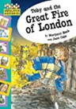 | 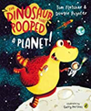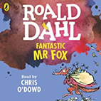 | 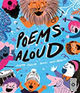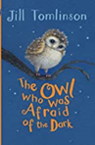 | 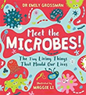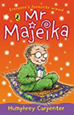 | 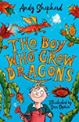 | 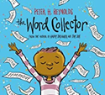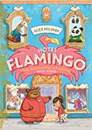
Reading | Tidy by Emily Gravett  Planet full of Plastic by Neal Layton | Knowledge Encyclopaedia Animal!  Online E-book  On a Sudden Hill by Linda Sarah and Beni Davies | The Great Kapok Tree by Lynne Cherry  The Crow’s Tale by Naomi Howarth | Great Fire of London by Emma Adams and James Weston Lewis.  The Day the Crayons Quit by Oliver Jeffers | The Book of Trees by Piotr Socha and Wojeiech Grajkowski  The Great Explorer by Chris Judge | Queen Victoria’s Bathing Machine by Gloria Whelan and Nancy Carpenter  The Lost Homework by Richard O’Neill and Kirstie Beautyman
English | Narrative  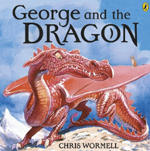  Non-Chronological Report  Terrific Tigers | Non-Chronological Report  Terrific Tigers  Postcard  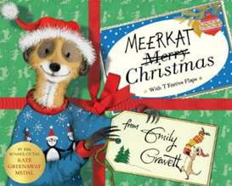 | Diary  Great Fire of London  Narrative (Didn’t do Building Boy- did Marvellous Itty Bitty)  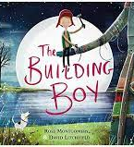 | Narrative  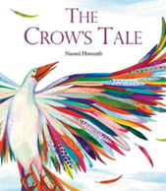  Instructions  How to make a bird feeder. | Persuasive Letter Narrative  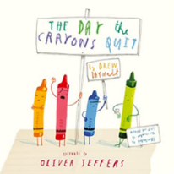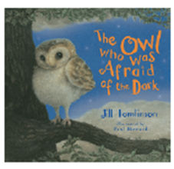 | Narrative  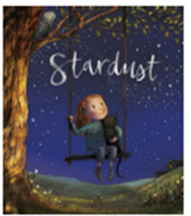  Poetry  If I were in charge of the world.
Maths | Unit 1: Numbers to 100  Unit 2: Addition and subtraction (1) | Unit 3: Addition and subtraction (2)  Unit 4: Properties of shape | Unit 5: Money  Unit 6: Multiplication and division (1)  Unit 7: Multiplication and division (2) | Unit 8: Length and height  Unit 9: Mass, capacity and temperature | Unit 10: Fractions  Unit 11: Time  Unit 12: Problem solving and efficient methods | Unit 13: Position and direction  Unit 14: Weight, volume and temperature
Science | Animals including humans | Animals including humans | Living things and their habitats | Living things and their habitats | Plants | Use of everyday materials
Computing | Information Technology around us | Digital Photography | Robot Algorithms | Pictograms | Making Music | An introduction to quizzes
D&T |  | Mechanisms  Wheels and Axles – Emergency Service Vehicle |  | Textiles  2D Shape to 3D – Design a puppet |  | Cooking and Nutrition  Making a salad
Art & Design | Drawing |  | Printing |  | Sculpture
History |  | The Great Fire of London |  | Explorers Through Time |  | Inventors that have changed the world
Geography | Continents and Oceans Part 2 inc. Small Area of the U.K. – Daventry |  | Comparing locations-Jamaica |  | Understanding the UK Part 2
RE | Core beliefs, traditions, and celebrations  Hinduism  Christianity | Core beliefs, traditions, and celebrations  Hinduism  Christianity | Key people and places  Judaism  Christianity | Key people and places  Judaism  Christianity | Important books and religious stories  Judaism  Hinduism  Christianity | Important books and religious stories  Judaism  Hinduism  Christianity
Music | Unit 1: Ourselves  Unit 3: Animals | MB- Twelve Bar Blues | Unit 8: Seasons  Unit 9: Weather | MB- Brahams Lullaby | Unit 3: Our Land  Unit 12: Travel | MB: Beethoven no. 9 Ode to Joy
MFL
PE | Real PE – Personal Cog  Games  - master basic movements including running, jumping, throwing and catching, as well as developing balance, agility and co-ordination, and begin to apply these in a range of activities.  - participate in team games, developing simple tactics for attacking and defending. | Real PE – Social Cog  Gym  - master basic movements including running, jumping, throwing and catching, as well as developing balance, agility and co-ordination, and begin to apply these in a range of activities. | Real PE – Cognitive Cog  Dance  - master basic movements including running, jumping, throwing and catching, as well as developing balance, agility and co-ordination, and begin to apply these in a range of activities.  - perform dances using simple movement patterns. | Real PE – Creative Cog  Assessed Gaps  - master basic movements including running, jumping, throwing and catching, as well as developing balance, agility and co-ordination, and begin to apply these in a range of activities.  - participate in team games, developing simple tactics for attacking and defending.  - perform dances using simple movement patterns. | Real PE – Physical Cog  Athletics  - master basic movements including running, jumping, throwing and catching, as well as developing balance, agility and co-ordination, and begin to apply these in a range of activities. | Real PE – Health & Fitness Cog  Assessed Gaps  - master basic movements including running, jumping, throwing and catching, as well as developing balance, agility and co-ordination, and begin to apply these in a range of activities.  - participate in team games, developing simple tactics for attacking and defending.  - perform dances using simple movement patterns.
PSHE | Relationships (InMAT) | Me and My Relationships (Scarf) / Valuing Difference (Scarf) | Living in the Wider World (InMAT) | Keeping Safe (Scarf) | Health and Well-being (InMAT) | Growing and Changing (Scarf) / Being My Best (Scarf)

