 | Autumn 1 | Autumn 2 | Spring 1 | Spring 2 | Summer 1 | Summer 2
Value | Respect | Unity | Honesty | Responsibility | Kindness | Resilience
British Value | Democracy. | The rule of law. | Individual Liberty | Individual Liberty | Mutual respect | Tolerance
Ongoing throughout the Year | Time to be taught daily, highlighting times during the day that match NC age related expectations (e.g. nearest minute, compare durations of events). Roman Numerals- small display within class and children write the Roman date in their maths books daily underneath the short numerical date.
Enrichment
Reading for Pleasure | 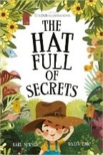 | 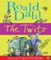 | 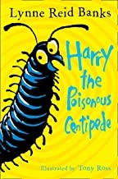 | 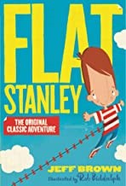 | 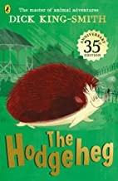 | 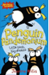
Reading | Mixed by Arree Chung  Little Red Riding Hood by Mara Alparin  Mr Magnolia By Quentin Blake  Funny Bones By Alan and Janet Ahlber  I am the seed that grew the tree  By Fiona Waters and Frann Preston-Gannon | You can’t take an elephant on a bus By Patricia  Cleveland-Peck and David  Tazzyman  The Tiger who came to tea  By Judith Kerr  Billy Goats Gruff by Mara Alparin  The Nativity Play by Nick Butterworth | The Invisible By Tom Perciva  What happened to you?  By James Catchpole and Karen Georg  United Kingdom: Travel for kids: The fun way to discover the UK  We are family  By Patricia Hegarty and Ryan Wheatcroft  Grandad’s Secret Giant by David Litchfield | Grandad’s secret Giant By David Litchfield – moved to Spr1  The Dark by Lemony Snicket  Daffodils (unknown author)  Nimesh the adventurer  By Ranjit Singh and Mehrdokbt Amin | The smile shop By Satoshi Kitamura  I am the seed that grew the tree  By Fiona Waters and Frann  Preston-Gannon  (Self-esteem and resilience)  Sully the Seahorse by Natalie Pritchard  The Emperor of Absurdia By Chris Riddell  Added – Billy and the Beast by Nadia Shireen.  Last Stop on Market Street by Matt De La Pena  Leo and the Octopus by Isabelle Marinov and Chris Nixon | Oof makes an ouch By Duncan Beedie  Expedition Diaries: African Savanna By Simon Chapman  Somebody swallowed Stanley by Sarah Roberts  The perfect shelter  By Clare Helen Welsh and Asa Gilland  Anita and the Dragons By Hannah Carmona and Anna Cunha
English | Narrative  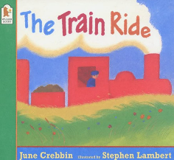  Recount  A trip to the woods | Poetry  Firework Night  Narrative  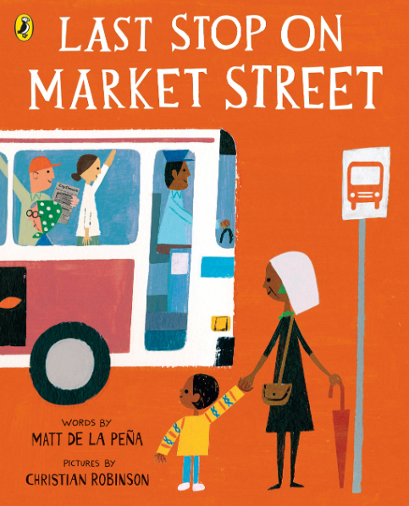 | 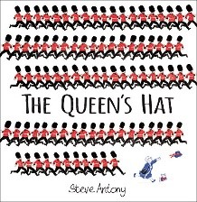  Narrative Narrative  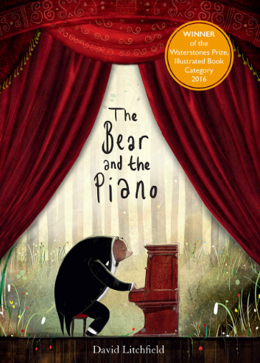 | 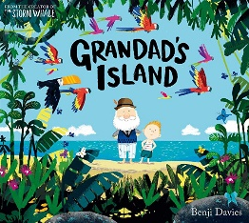  Narrative  Report  Toys from the past | Narrative  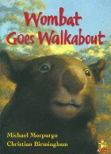  Non chronological report  Seasons (Based on the book by Hannah Pang) | 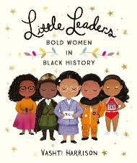  Biography Narrative  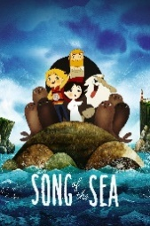
Maths | Unit 1: Numbers to 10  Unit 2: Part-whole within 10  Unit 3: Addition within 10 | Unit 4: Subtraction within 10  Unit 5: 2D and 3D shapes | Unit 6: Numbers to 20  Unit 7: Addition and subtractions within 20  Unit 8: Numbers to 50 | Continued – Unit 8: Numbers to 50  Unit 9: Introducing length and height  Unit 10: Introducing mass and capacity | Unit 11: Multiplication and division  Unit 12: Fractions  Unit 13: Position and direction | Unit 14: Numbers to 100  Unit 15: Money  Unit 16: Statistics
Science | Animals including humans | Living things | Materials | Materials | Seasons | Plants
Computing | Technology around us | Digital painting | Programming A (moving a robot) | Grouping Data | Digital write | Programming (animations)
D&T |  | Structures  Free Standing Structures |  | Cooking and Nutrition Preparing Fruit and Veg  Fruit Kebabs |  | Mechanisms  Sliders and Levers
Art & Design | Drawing |  | Collage |  | Painting
History |  | The Gun Powder Plot |  | Me and My Grandparents |  | Florence Nightingale
Geography | Simple Fieldwork of School |  | Understanding the U.K. Part 1 |  | Continents & Oceans Part 1
RE | Core beliefs, traditions, and celebrations  Christianity  Judaism | Core beliefs, traditions, and celebrations  Christianity  Judaism | Key people and places  Christianity | Key People and places  Christianity | Important books and religious stories  Christianity  Judaism | Important books and religious stories  Christianity  Judaism
Music | MB- How to play | Unit 1: Ourselves  Unit 3: Animals | MB- Twinkle Twinkle Little Star | Unit 4: Weather  Unit 7: Our School | MB- Star Wars Theme Tune | Unit 11: Travel  Unit 12: Pitch
MFL
PE | Real PE – Personal Cog  Games  - master basic movements including running, jumping, throwing and catching, as well as developing balance, agility and co-ordination, and begin to apply these in a range of activities.  - participate in team games, developing simple tactics for attacking and defending | Real PE – Social Cog  Gym  - master basic movements including running, jumping, throwing and catching, as well as developing balance, agility and co-ordination, and begin to apply these in a range of activities. | Real PE – Cognitive Cog  Dance  - master basic movements including running, jumping, throwing and catching, as well as developing balance, agility and co-ordination, and begin to apply these in a range of activities.  - perform dances using simple movement patterns. | Real PE – Creative Cog  Assessed Gaps  - master basic movements including running, jumping, throwing and catching, as well as developing balance, agility and co-ordination, and begin to apply these in a range of activities.  - participate in team games, developing simple tactics for attacking and defending.  - perform dances using simple movement patterns. | Real PE – Physicall Cog  Athletics  - master basic movements including running, jumping, throwing and catching, as well as developing balance, agility and co-ordination, and begin to apply these in a range of activities. | Real PE – Health & Fitness Cog  Assessed Gaps  - master basic movements including running, jumping, throwing and catching, as well as developing balance, agility and co-ordination, and begin to apply these in a range of activities.  - participate in team games, developing simple tactics for attacking and defending.  - perform dances using simple movement patterns.
PSHE | Relationships (InMAT) | Valuing Difference (Scarf) | Living in the Wider World (InMAT) | Keeping Safe (Scarf) | Health and Well-being (InMAT) | Rights and Responsibilities (Scarf) / Growing and Changing (Scarf)

