

Ashby Fields Primary School
Year Group
Writing Maps


AFPS Writing Map – Autumn
Year 1 | Autumn 1 |  |  | Year 1 | Autumn 2
JC Writing Unit | Narrative  The Train Ride | Non-fiction  Recount |  | JC Writing Unit | Poetry  Firework Night | Narrative  Last Stop on Market Street
Length | 13 + 2 independent writing | 13 days + 5 independent writing |  | Length | 8 days + 5 independent writing | 10 days + 5 independent writing
Stimulus | The Train Ride by June Crebbin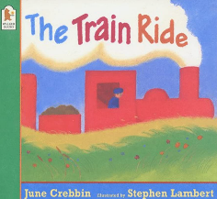 | 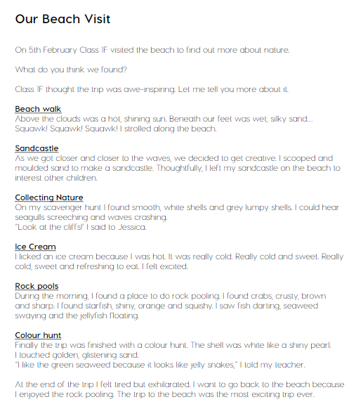  Our Trip to the Woods (example in plan) |  | Stimulus | Based on the poem ‘Firework Night’ by Andrew Collett  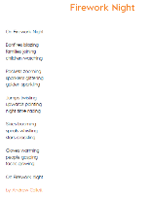 | 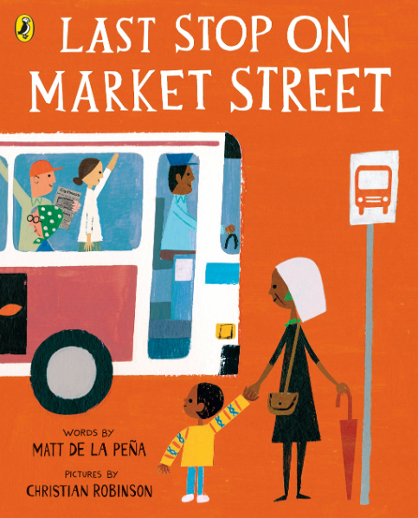  Last Stop on Market Street by Matt De La Pena

Year 2 | Autumn 1 |  |  | Year 2 | Autumn 2
JC Writing Unit | Narrative  George and the dragon | Non-Chronological Report  Terrifying Tigers |  | JC Writing Unit | Non-Chronological Report  Terrifying Tigers | Postcard  Meerkat Christmas
Length | 13 days + 5 independent write | 9 days + 5 independent write |  | Length | 13 days + 5 independent write | 11 days + 5 day write
Stimulus | George and the Dragon 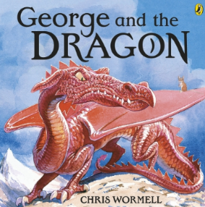 | (model text)  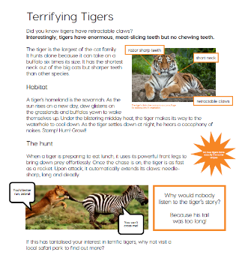 |  | Stimulus | (model text)  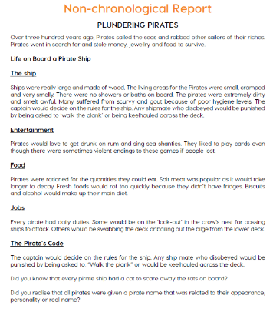 | Meerkat Christmas by Emily Gravett  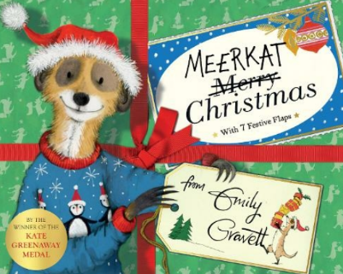

Year 3 | Autumn 1 |  |  | Year 3 | Autumn 2
JC Writing Unit | Narrative  The Star in the Jar | Poetry  (Seasonal poetry)  Autumn is Here |  | JC Writing Unit | Narrative  The Incredible Book Eating Boy | Non-Fiction  (Non-Chronological report)  Skeletons and Muscles
Length | 13 days + 5 independent writing | 13 days + 3 independent writing |  | Length | 10 days + 5 independent writing | 13 days + 5 independent writing
Stimulus | The Star in the Jar  by Sam Hay  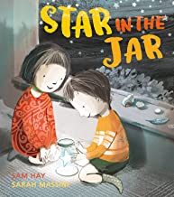 | Summer is Here  within planning  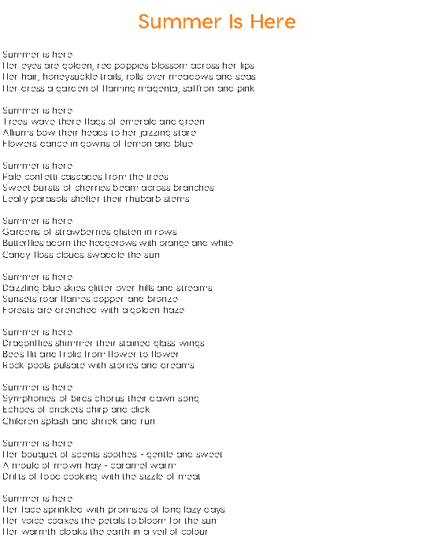 |  | Stimulus | The incredible book eating boy  by Oliver Jeffers  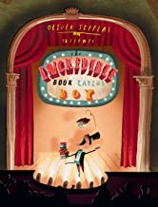 | An Anthology of Intriguing Animals  by Ben Hoare  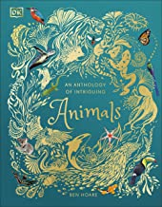

Year 4 | Autumn 1 |  |  | Year 4 | Autumn 2
JC Writing Unit | Narrative  The lost thing | Narrative  The feast |  | JC Writing Unit | Narrative  Aladdin and the enchanted lamp | Poem  The River
Length | 14 lessons + 5 independent write | 13 lessons + 5 independent write |  | Length | 8 lessons + 4 independent write | 9 lessons + 7 independent write
Stimulus | 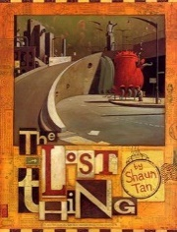 | 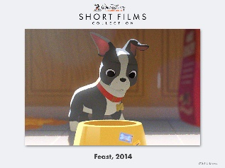 |  | Stimulus | 

Year 5 | Autumn 1 |  |  | Year 5 | Autumn 2
JC Writing Unit | 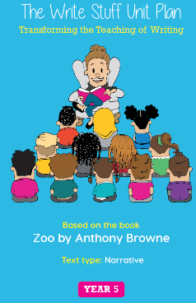 | 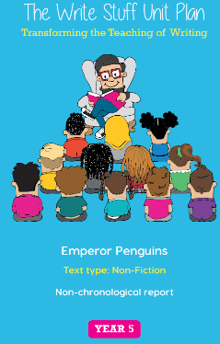 |  | JC Writing Unit | 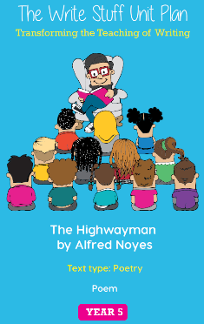 | 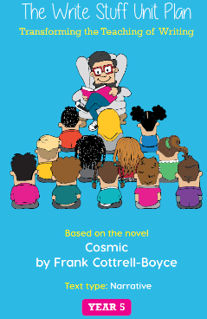
Length | 15 days (3 weeks) | 19 days (4 weeks) |  | Length | 20 days (4 weeks) | 12 days 3 weeks)
Stimulus | 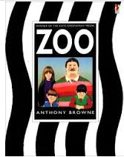  Narrative | 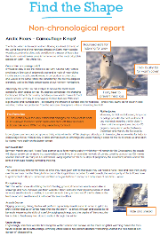 |  | Stimulus | 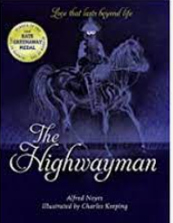  Poetry | 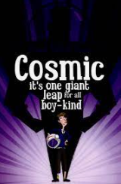  Narrative

Year 6 | Autumn 1 |  |  | Year 6 | Autumn 2
JC Writing Unit | Narrative  Hansel & Gretel | Newspaper Report  Goldilocks |  | JC Writing Unit | Narrative  The Journey | Persuasive Letter  Letter to Mr Scrooge
Length | 5 days + 5 days independent | 9 days + 5 days independent |  | Length | 13 days + 5 days independent | 17 days + 5 days independent
Stimulus | Hansel & Gretel  By Neil Gaiman  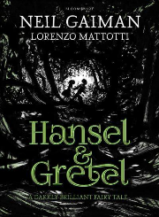 |  |  | Stimulus | The Journey  by Francesca Sanna  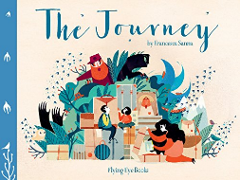

AFPS Writing Map – Spring
Year 1 | Spring 1 |  |  | Year 1 | Spring 2
JC Writing Unit | Narrative  The Bear and the Piano | Narrative  The Queen’s Hat |  | JC Writing Unit | Narrative  Grandad’s Island | Non-fiction  Report
Length | 8 days + 5 independent writing | 7 days + 5 independent writing |  | Length | 14 days + 5 independent writing | 11 days + 5 independent writing
Stimulus | 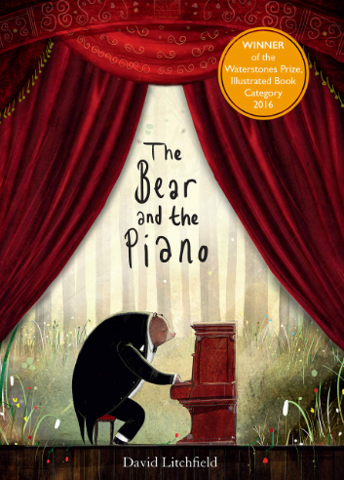  The Bear and the Piano by David Litchfield | 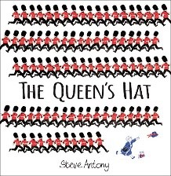  The Queen’s Hat by Steve Anthony |  | Stimulus | 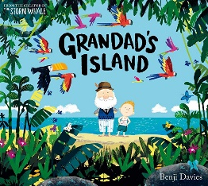  Grandad’s Island by Benji Davis | 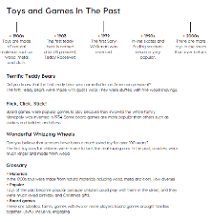  Toys from the Past (example in plan)

Year 2 | Spring 1 |  |  | Year 2 | Spring 2
JC Writing Unit | Diary  Great Fire of London | Narrative  The Building Boy |  | JC Writing Unit | Narrative  A Crow’s Tale | Instructions  How to make a bird feeder
Length | 11 days + 5 days independent write | 13 days + independent write |  | Length | 11 days + 5 independent write | 11 days + 5 independent write
Stimulus | Great Fire of London by Emma Adams  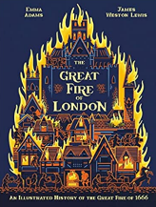 | The Building Boy by Ross Montgomery  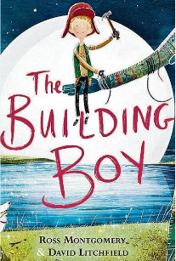 |  | Stimulus | A Crow’s Tale by Naomi Howarth  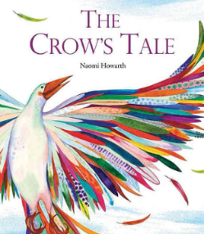 | (model text)  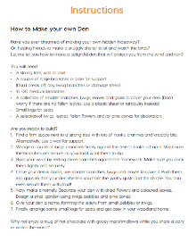

Year 3 | Spring 1 |  |  | Year 3 | Spring 2
JC Writing Unit | Narrative  The Secret of Black Rock | Poetry  I asked the little boy who cannot see |  | JC Writing Unit | Narrative  Flood | Diary  Historical Diary.  Roman Diary - The Journal of Iliona – A Young Slave.
Length | 12 days + 5 independent writing | 7 days + 5 independent writing |  | Length | 13 days + 5 independent writing | 11 days + 5 independent writing
Stimulus | The Secret of Black Rock  by Joe Todd-Stanton  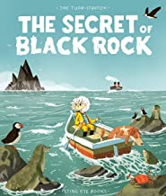 | The Colours of History  by Clive Gifford  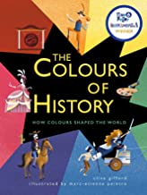 |  | Stimulus | Flood  by Alvaro F. Villa  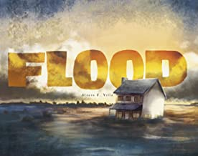 | The Journal of Iliona: A Young Slave  by Richard Platt and David Parkin  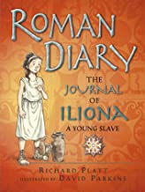

Year 4 | Spring 1 |  |  | Year 4 | Spring 2
JC Writing Unit | Non- fiction  Digestion | Narrative  Bike boy |  | JC Writing Unit | Newspaper report  Wizards of once | Narrative  Charlie and the chocolate factory
Length | 16 lessons + 5 independent write | 13 lessons + 5 independent |  | Length | 11 lessons + 5 independent write | 10 lessons + 5 independent write
Stimulus | 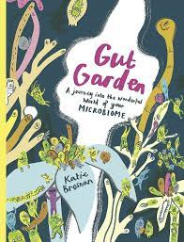 | 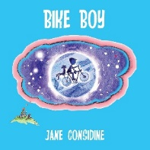 |  | Stimulus | 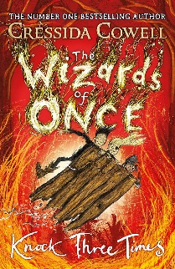 | 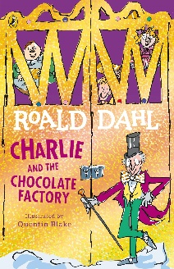

Year 5 | Spring 1 |  |  | Year 5 | Spring 2
JC Writing Unit | 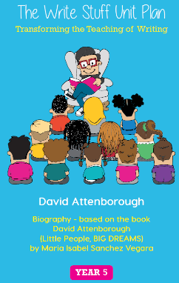 | 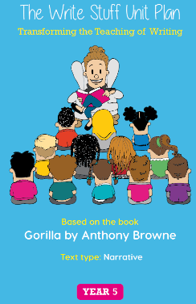 |  | JC Writing Unit | 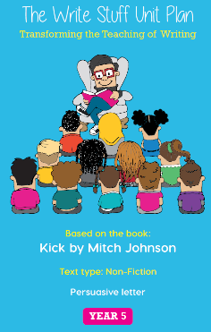 | 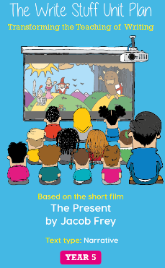
Length | 19 days (4 weeks) | 18 days (3.5 weeks) |  | Length | 19 days (4 weeks) | 17 days (3.5 weeks)
Stimulus | 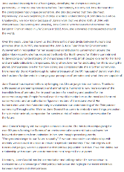  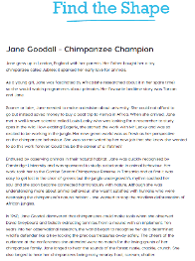 | 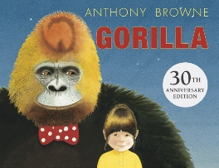 |  | Stimulus | 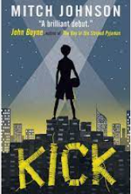  Persuasive Letter |   The Present by Jacob Frey (Short Film)

Year 6 | Spring 1 |  |  | Year 6 | Spring 2
JC Writing Unit | Narrative  The Graveyard Book | Postcard  Fairy Tale Characters in Prison |  | JC Writing Unit | Narrative  Kensuke’s Kingdom | Non-Chronological Report  Everest
Length | 14 days + 5 days | 4 days + 5 days independent |  | Length | 10 days + 5 days independent
Stimulus | The Graveyard  By Neil Gaiman  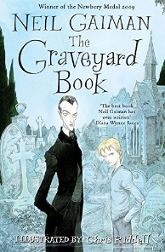 |  |  | Stimulus | Kensuke’s Kingdom  By Michael Morpurgo  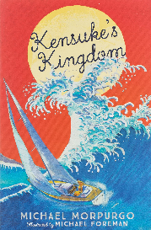 | Everest  by Sangma Francis and Lisk Feng  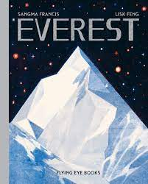

AFPS Writing Map – Summer
Year 1 | Summer 1 |  |  | Year 1 | Summer 2
JC Writing Unit | Narrative  Wombat goes Walkabout | Non-fiction  Information Text |  | JC Writing Unit | Non-fiction  Biography | Narrative  Song of the Sea
Length | 11 days + 5 independent writing | 7 days + 5 independent writing |  | Length | 13 days + 5 independent writing | 11 days + 5 independent writing
Stimulus | 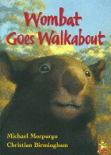  Wombat goes walkabout by Michael  Morpurgo | Seasons (Based on the book by Hannah Pang)  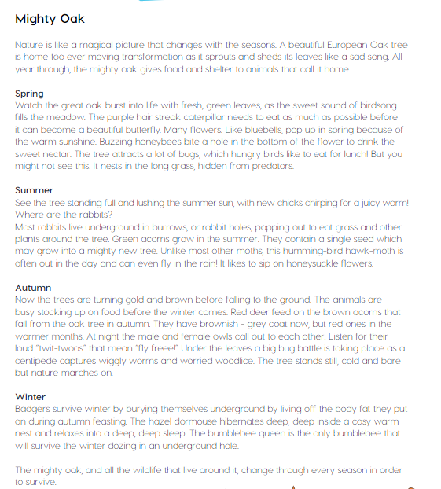 |  | Stimulus | Bold Women in Black History by Vashti Harrison  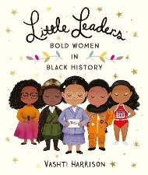 | Song of the Sea by Studio Canal  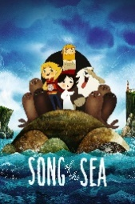  (film clips)

Year 2 | Summer 1 |  |  | Year 2 | Summer 2
JC Writing Unit | Persuasive letter  The Day the Crayon’s Quit | Narrative  The Owl who was Afraid of the Dark |  | JC Writing Unit | Narrative  Stardust | Poetry  If I Were in Charge of the World
Length | 12 days + 5 independent write | 11 days + 5 independent write |  | Length | 12 days + 5 independent write | 11 days + 5 independent
Stimulus | The Day the Crayon’s Quit by Drew Daywalt  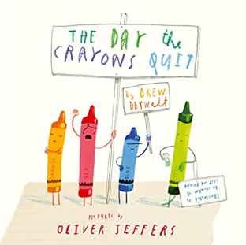 | The Owl who was Afraid of the Darl by Jill Tomlinson  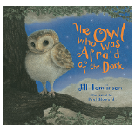 |  | Stimulus | Stardust by Jeanne Willis  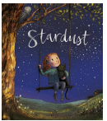 | (model text)  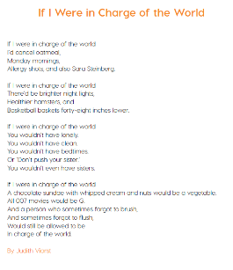

Year 3 | Summer 1 |  |  | Year 3 | Summer 2
JC Writing Unit | Narrative  The True Story of the Three Little Pigs | Non-Fiction  (Instructions)  My Strong Mind |  | JC Writing Unit | Narrative  The Wolves in the Walls | Non-Fiction  (Persuasive writing - Holiday Brochures)
Length | 13 days + 5 independent writing | 12 days + 5 independent writing |  | Length | 13 days + 5 independent writing | 11 days + 5 independent writing
Stimulus | The True Story of the Three Little Pigs  by Jon Scieszka  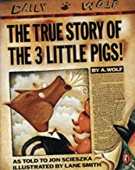 | My Strong Mind  by Niels Van Hove  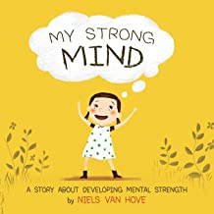 |  | Stimulus | The wolves in the Walls  by Neil Gaiman  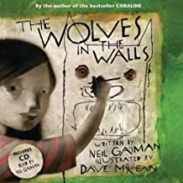 | Skara Brae  by Dawn Finch  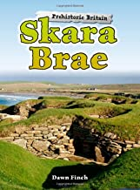

Year 4 | Summer 1 |  |  | Year 4 | Summer 2
JC Writing Unit | Narrative  The Iron Man | Narrative  The Whale |  | JC Writing Unit | Non-fiction – persuasive  Sicily holiday brochure | Narrative  The princess and the pea
Length | 12 lessons + 5 independent write | 13 lessons + 5 independent write |  | Length | 13 lessons + 5 independent write | 12 lessons + 5 independent write
Stimulus | 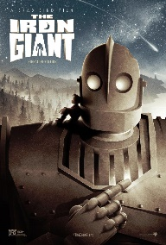 | 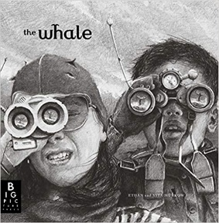 |  | Stimulus | 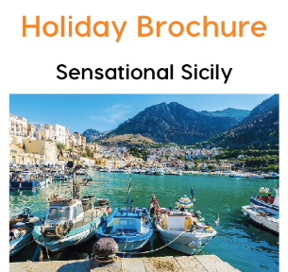 | 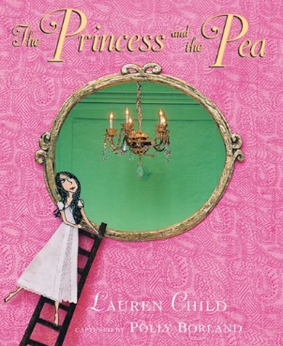

Year 5 | Summer 1 |  |  | Year 5 | Summer 2
JC Writing Unit | 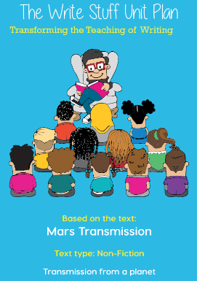 | 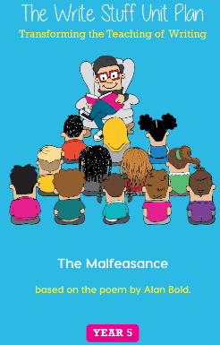 |  | JC Writing Unit | 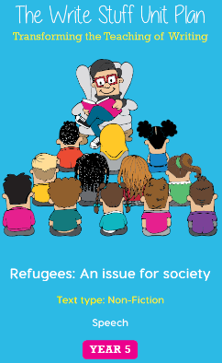 | 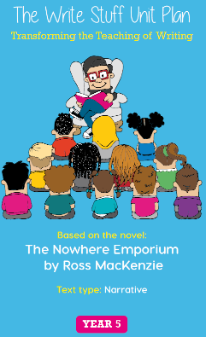
Length | 20 days (4 weeks) | 19 days (4 weeks) |  | Length | 17 days (3.5 weeks) | 18 days (3 .5 weeks)
Stimulus | 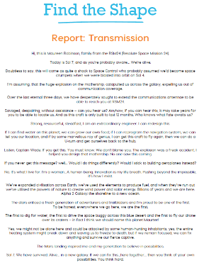 | 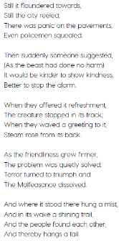  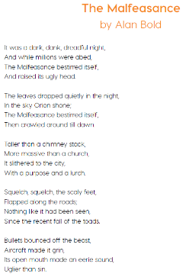 |  | Stimulus | 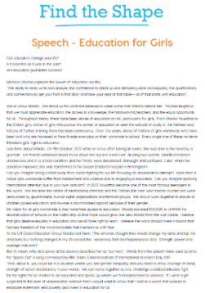 | 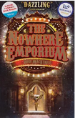

Year 6 | Summer 1 |  |  | Year 6 | Summer 2
JC Writing Unit | Narrative | Internal Monologue |  | JC Writing Unit | Recount  Hotel Review  (Formal letter) | Poetry  Hope-o-potamus
Length | 13 days + 5 days independent | 10 days + 5 days independent |  | Length |  | 13 days + 5 days independent
Stimulus | 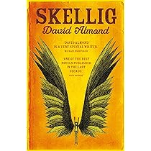 |  |  | Stimulus |  | Hope-o-potamus  By Greg James and Chris Smith  

