The Writing Curriculum at AFPS

Intent

At Ashby Fields Primary School we are committed to providing a high-quality writing experience that instils a love of writing and explores rich language with our learners. Our pupils are given the tools to be able to communicate their thoughts, ideas and emotions effectively.
We aim to create writers who speak and write fluently so that they can communicate their ideas and emotions to others. Reading and a love of literature is an integral part of our aim to produce authors of high-quality writing, through its role in engaging the reader, stimulating the authors own creativity and modelling composition and transcription.
Implementation

We follow the National Curriculum and use the Jane Considine structured approach for planning, teaching and assessing writing. This promotes high standards of language and literacy by equipping pupils with a strong command of the spoken and written word, and to develop their love of language through widespread reading for enjoyment.

We believe that high quality vocabulary and texts are the key to developing fluent and engaged writers; exposing our children to these, enables them to utilise what they have experienced to create inspired, interesting and accurate writing. We make use of a wide variety of tools to build the required skills and knowledge the children can apply in their writing.
- Providing a hook for children based on firsthand, wow experiences that are linked to our writing themes
- Providing opportunities to collaborate with others
- Using drama to help generate ideas and to inspire
- Ensuring that children have opportunities to write at length
- Scaffolding writing with FANTASTICs – 9 reasons for writing
Read, Write, Inc

In Early Years and Key Stage 1, Read, Write, Inc for phonics is taught daily and is used to create the building blocks for writing with a core focus on segmenting sounds in words to spell them, using our ‘Fred Fingers’ to identify the number of sounds in a word and pinching them on our fingers before we write them.
Vocab Ninja
Children in Key Stage 1 who have completed the RWI programme move into Vocabulary Ninja lessons where they receive explicit teaching of new vocabulary and additional opportunities to use these in context in their writing. They also focus on core spelling, punctuation and grammar rules through each week.
The Write Stuff
We build upon the RWI foundations through our writing curriculum based on the Jane Considine approach ‘The Write Stuff.’ This begins with Grammar Bag in Early Years to support the functions of writing and develop pupil creativity and vocabulary alongside using story sketchers to provide opportunities to develop emergent writing.

As pupils move up through the school, we continue to teach using the same approach, ‘The Write Stuff,’ where teachers prepare children in daily writing lessons by modelling the ideas, grammar and techniques of writing. The Write Stuff consists of 3 main strands to develop children’s writing skills.
- Use of FANTASTICs to build the vocabulary and phrases needed within writing.
- Sentence stacking – building pupils’ confidence by developing writing sentence by sentence, and scaffolding writing.
- Chunking the learning – breaking the content into short, snappy chunks to keep children engaged and interested using ‘Inspire, Model and Empower’ steps of learning.
- Children are taught under the structure of ‘The Writing Rainbow.’

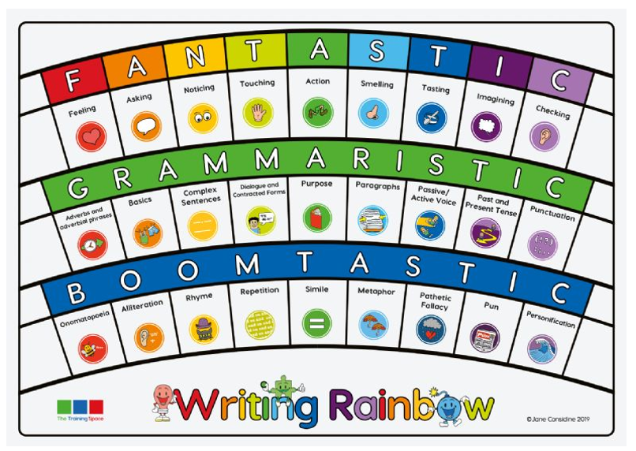

The FANTASTICs are 9 lenses that writing can be looked at and analysed through. This helps the children to understand the concept of stylistics (functional grammar) and helps them to understand the purpose of each sentence that they write and what the intent is for the reader.
These lenses are used in order to analsye the purpose of sentence when reading and then in turn to help children decide on the purpose of their sentence when writing.
The 9 GRAMMARISTICs cover national curriculum requirements, capturing the broad spectrum of key grammar knowledge. Discrete grammar sessions are also taught to ensure specific grammar knowledge is taught and revisited.
The BOOMTASTICs capture the ten powerful ways to add drama and poetic devices to writing. They help children structure their work, teaching them to showcase their writing voice, demonstrate originality and to take risks in a bid to capture the truth of a situation.
Planning
Teachers plan using the AFPS Whole School Writing Progression Document, based upon the National Curriculum and Jane Considine writing expectations. Alongside this they follow a writing map of Jane Considine units, carefully chosen so that across the school, pupils are exposed to a variety of genres and writing styles and have opportunities to develop their skills and knowledge in all areas of writing.
Each half term pupils are taught one narrative writing unit and one non-fiction or poetry unit. These units are taught over several weeks and culminate with an independent piece of writing. Children plan their independent writing first and are taught how to edit their completed work.

Handwriting

We recognise that fluent handwriting is part of building automaticity when writing, enabling children to focus on careful choices in other areas of their writing. Expectations with regard to handwriting and presentation are high and children are encouraged to take pride in their work at all times. We teach handwriting using the Kinetic Letters scheme and resources.

Handwriting begins in the EYFS with mark-making and patterns. All pupils are given access to a wide range of opportunities to practise early fine motor skills. Pupils are encouraged to develop fluent lines and emergent writing is encouraged. We recognise that for various reasons, many children do not start school with the strength needed for writing so our chosen approach focuses on making bodies strong before writing. This enables children to build the core strength, gross motor skills and fine motor skills needed for writing.

Correct letter formation is taught and modelled in a sequence of letter families that have similar movements. Children become familiar with “Brave” and “Scared” monkey to support them with letter sizing. Correct pencil grip, posture and positioning of paper/books are also emphasised during these sessions. This begins in EYFS and is taught regularly in Key Stage One and into Key Stage Two as required.

Children finding handwriting more challenging may be in receipt of physical literacy interventions or other fine motor interventions to support their development.

Cross Curricular Links

As a team we are truly passionate about the value of language. We recognise that opportunities are happening all the time in a classroom and in the school. Language is taught in specific English lessons, but children are also practising and using their skills constantly across all subjects. Teachers seek to take advantage of such opportunities and make cross-curricular links. We will plan for pupils to practise and apply the skills, knowledge and understanding acquired through English lessons to other areas of the curriculum. This may be through extended writing in other areas of the curriculum, such as Geogrpahy, History and Science to showcase the children’s transferrable literacy skills.

Writing Assessment

We firmly believe in the power of immediate, personalised feedback, so much informal assessment is done ‘pen-in-hand’ by teachers during lessons. Being next to a child and having a conversation in the moment about their work has far more impact than lengthy written feedback in many instances, so adults create classrooms where this dialogue is possible and powerful. Feedback may be provided in other ways, following the school’s feedback and marking policy. This formative assessment may be recorded on a whole class feedback sheet which can then be used to feed in to future teaching and planning in order to swiftly address misconceptions, prompt deeper thinking or ensure clarity of understanding.

Teachers make regular assessments against the National Curriculum objectives using writing frameworks. The frameworks used are aligned to both the National Curriculum and ‘The Write Stuff’ approach for each year group. This includes rating writing against a set of criteria along with formative assessment within the classroom, identifying gaps and next steps to improve writing. Teachers and support staff work hard to identify children falling behind early, and provide scaffolds, modelling and support to help children to make progress in their writing.

Metacognition

Research shows that children who are able to read fluently before they are 7 years old, have a stronger working memory. The working memory is where instructions and new concepts reside in the first instance and lasts no more than a minute or two. Children with strong working memories will be able to receive a list of instructions and follow them with ease. Children who have difficulties with their working memory will need supportive strategies in order to remove that cognitive load and allow them to focus on the core learning in smaller steps. Our teachers plan ‘experience’ days which may include trips, visitors and drama. This memory will evoke the emotions of excitement, enjoyment and engagement, helping children recall the event within their memory. Lessons that link to prior learning (within the year, or earlier in the schooling journey) or to the children’s personal experience ensures that that knowledge of the world around us is locked in their long-term memory. This also ensures planned opportunities for spaced retrieval, building upon children’s previous learning or experiences. Many of our chosen strategies for teaching English incorporate a multisensory approach. Multisensory activities are based on whole brain learning. This means teaching involving multiple areas in the brain. Adding auditory, physical or visual components to teaching aids better connections and longterm memory. We also use the “I do, we do, you do” strategy across our curriculum which is rooted in metacognition. This allows children to experience clear models and examples before being guided in their understanding and gradually becoming more independent.
As a school, we use Widgit symbols to support all our learners including those with SEND and reduce cognitive overload. These symbols and pictures are used across the school and curriculum to support the development of spoken and written language development. Practical and written scaffolds are used to support children in learning the steps for independent writing.

Effectiveness of Leadership and Management

The subject leader has responsibility for the following key areas:

- Effectively leading the ‘writing triad’
- Strategic direction and development to ensure high standards of teaching and learning
- Policy development
- Leading and managing staff in their subject area, including auditing and supporting colleagues in CPD.
- Ensuring efficient and effective deployment of staff and resources.
- To carry out subject specific monitoring activities in order to evaluate provision. This may include: analysing assessment data; visits to lessons; looking at children’s work; speaking to pupils

Monitoring

This policy and information report will be reviewed by English subject lead every year. It will also be updated if any changes to the information are made during the year. It will be approved by the governing body.

